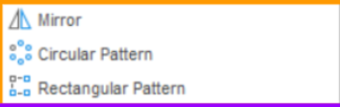

Mirror:

Draw something!

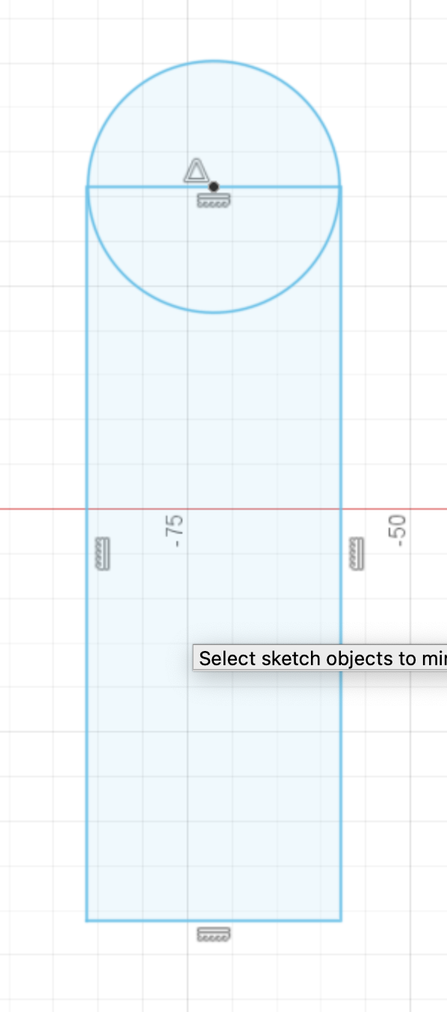

Hit the mirror icon:

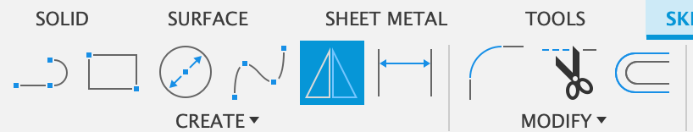

Click on the objects you want to mirror

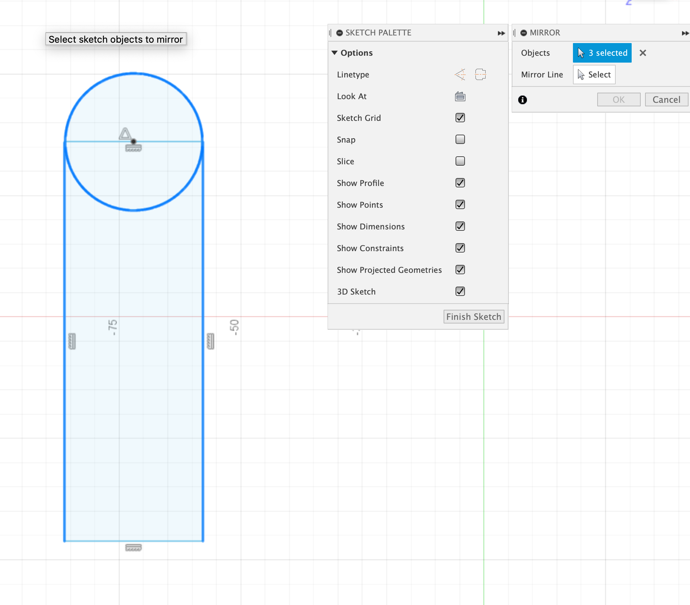

Then hit the mirror line “select” button and click on your mirror line.

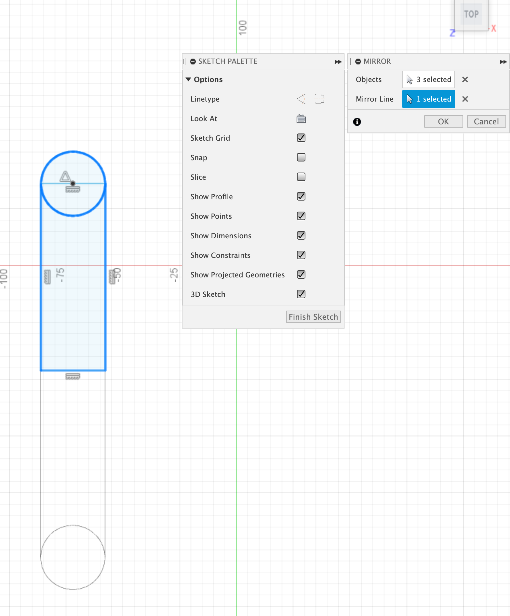

Click “OK” and you are done!

# Circular Pattern:

This is good for not causing Fusion to crash when you want to create lots of little things

Draw a circle and place something on it:

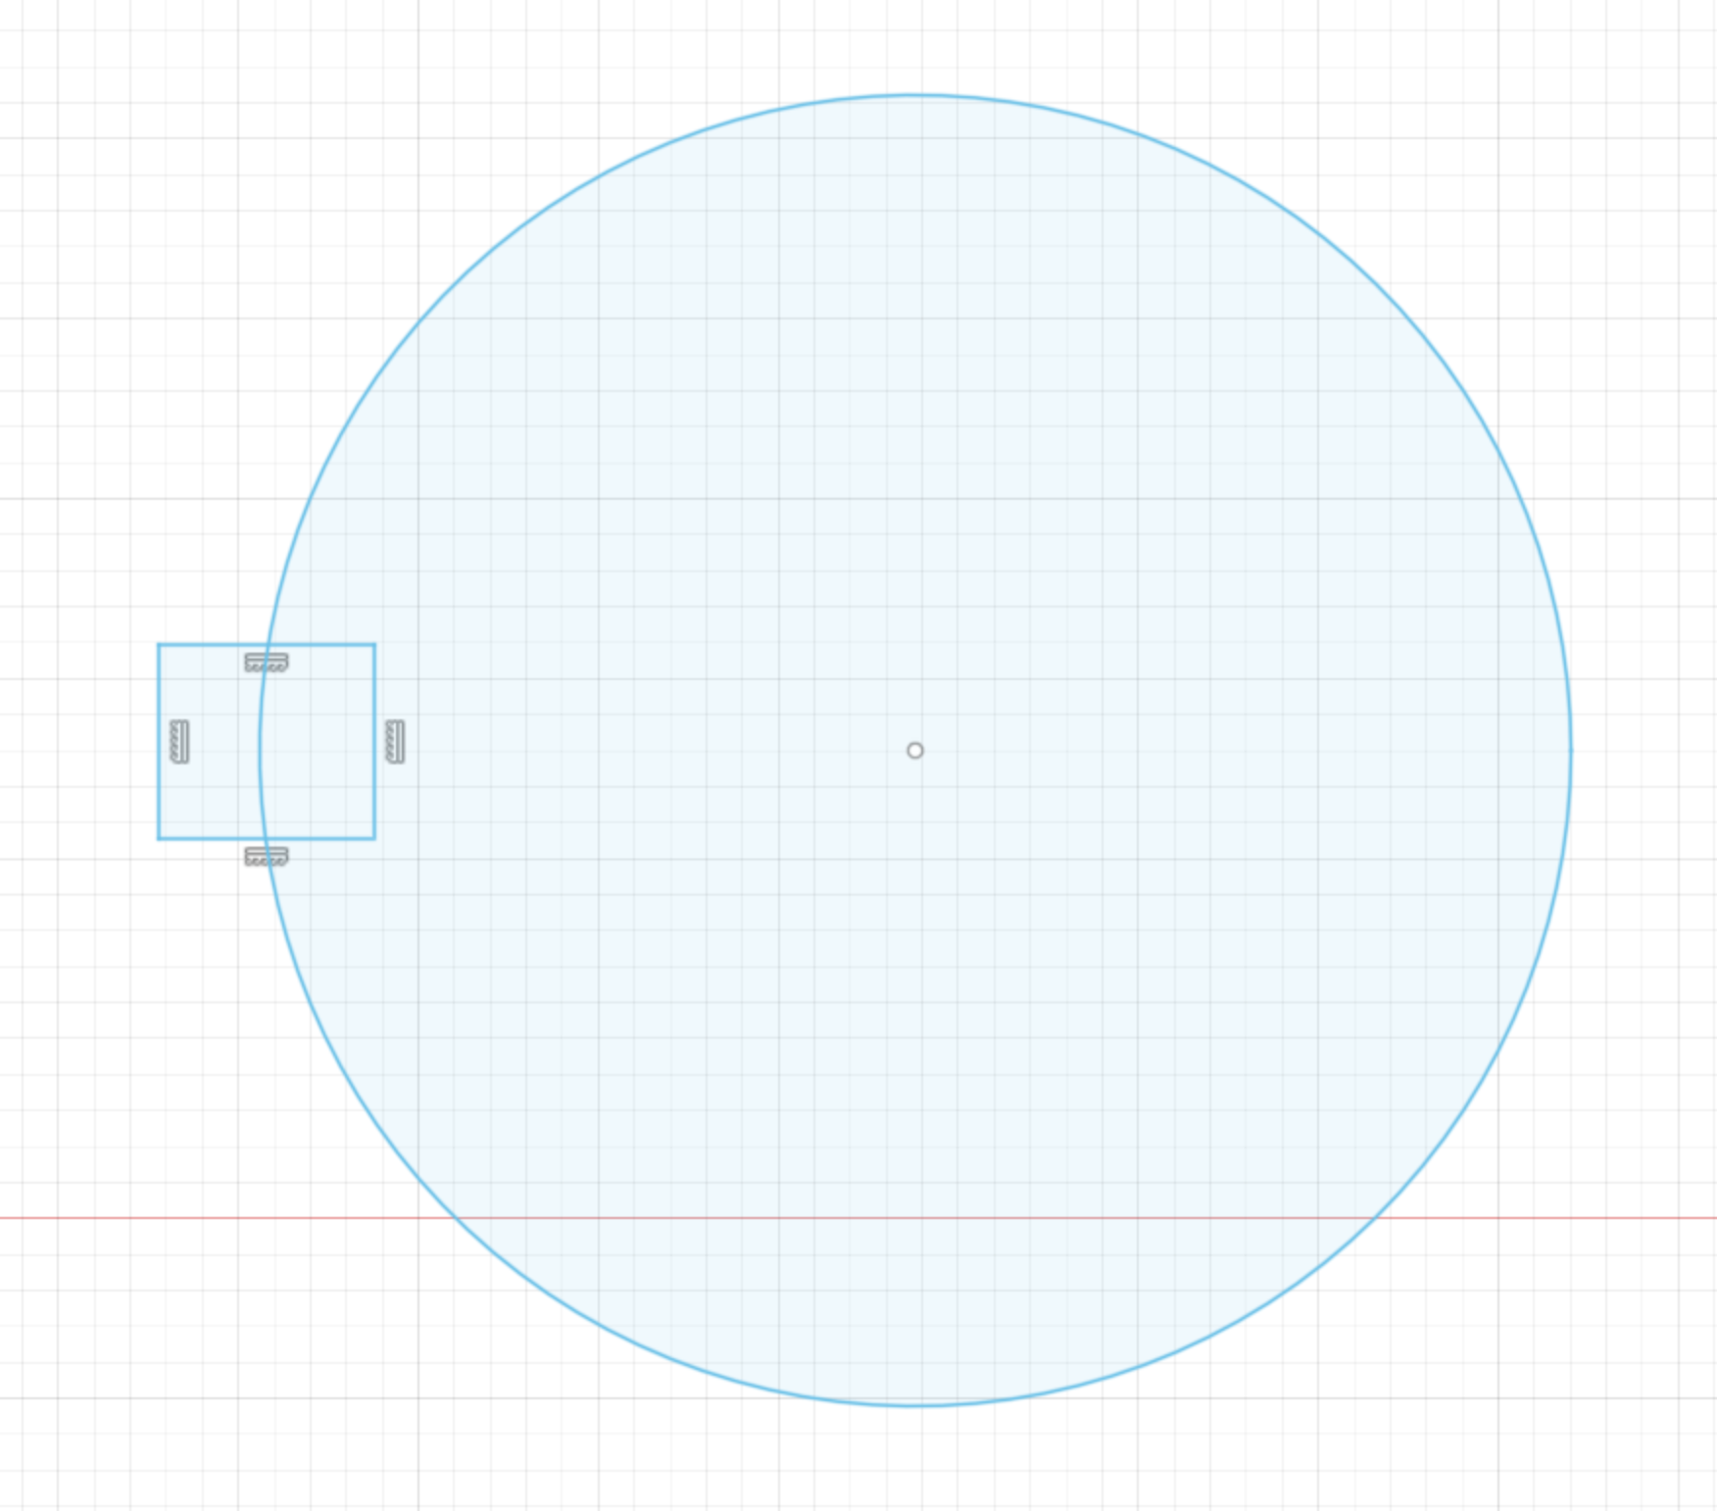

Hit “circular pattern”:

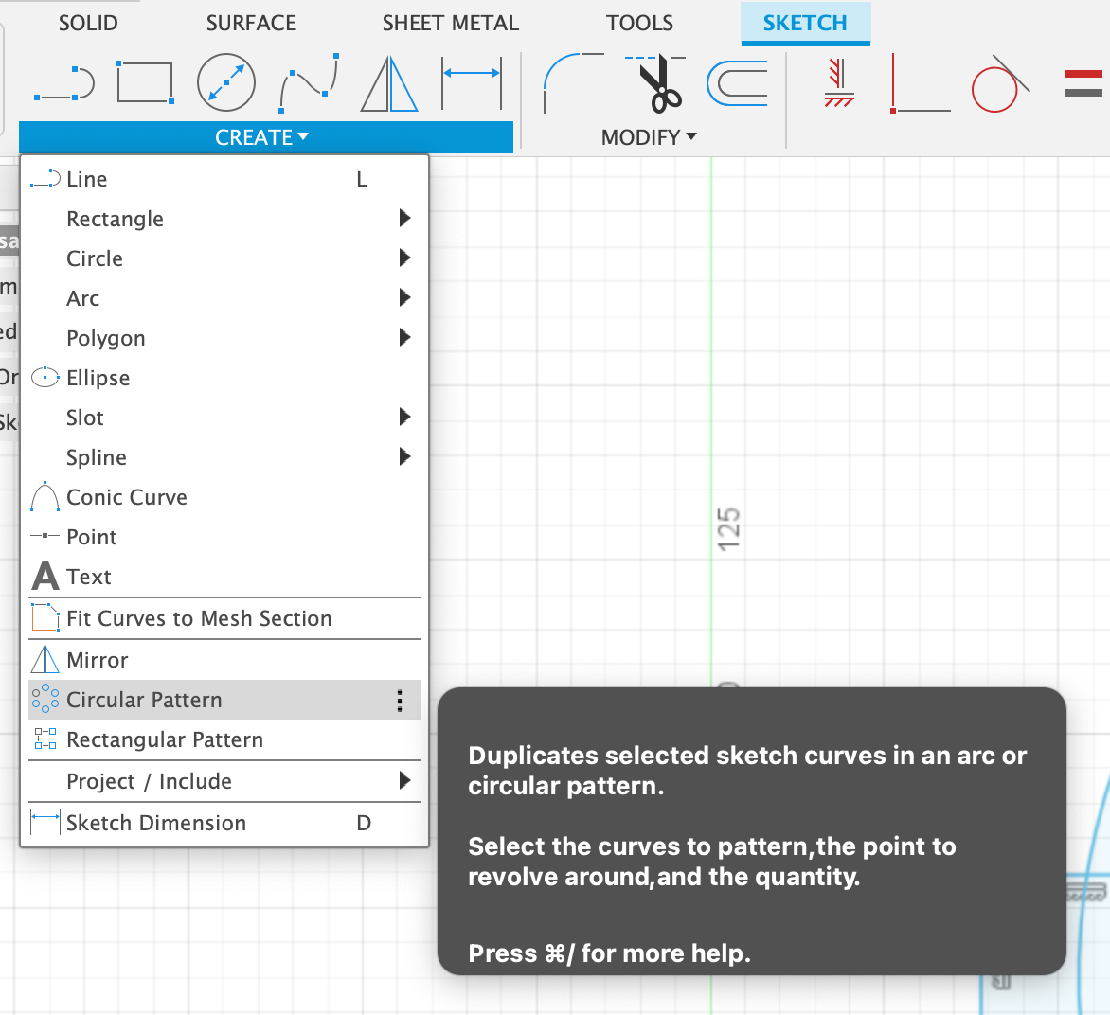

Click on your objects to pattern:

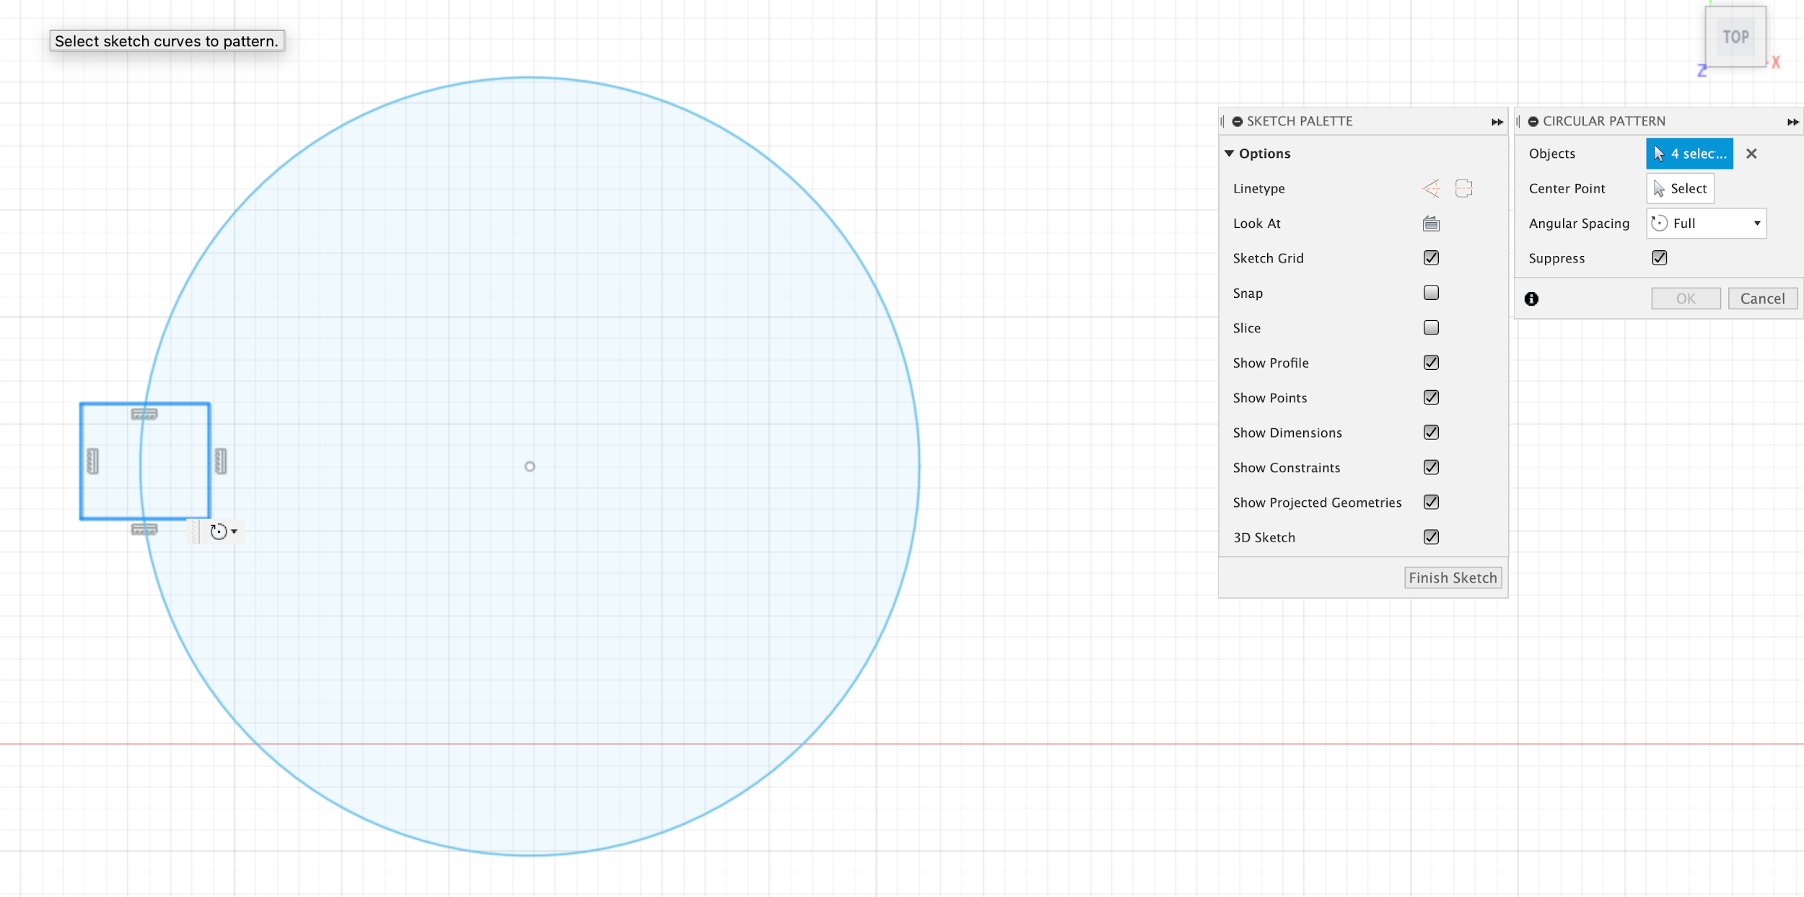

Hit center point “select” and click on the circle center:

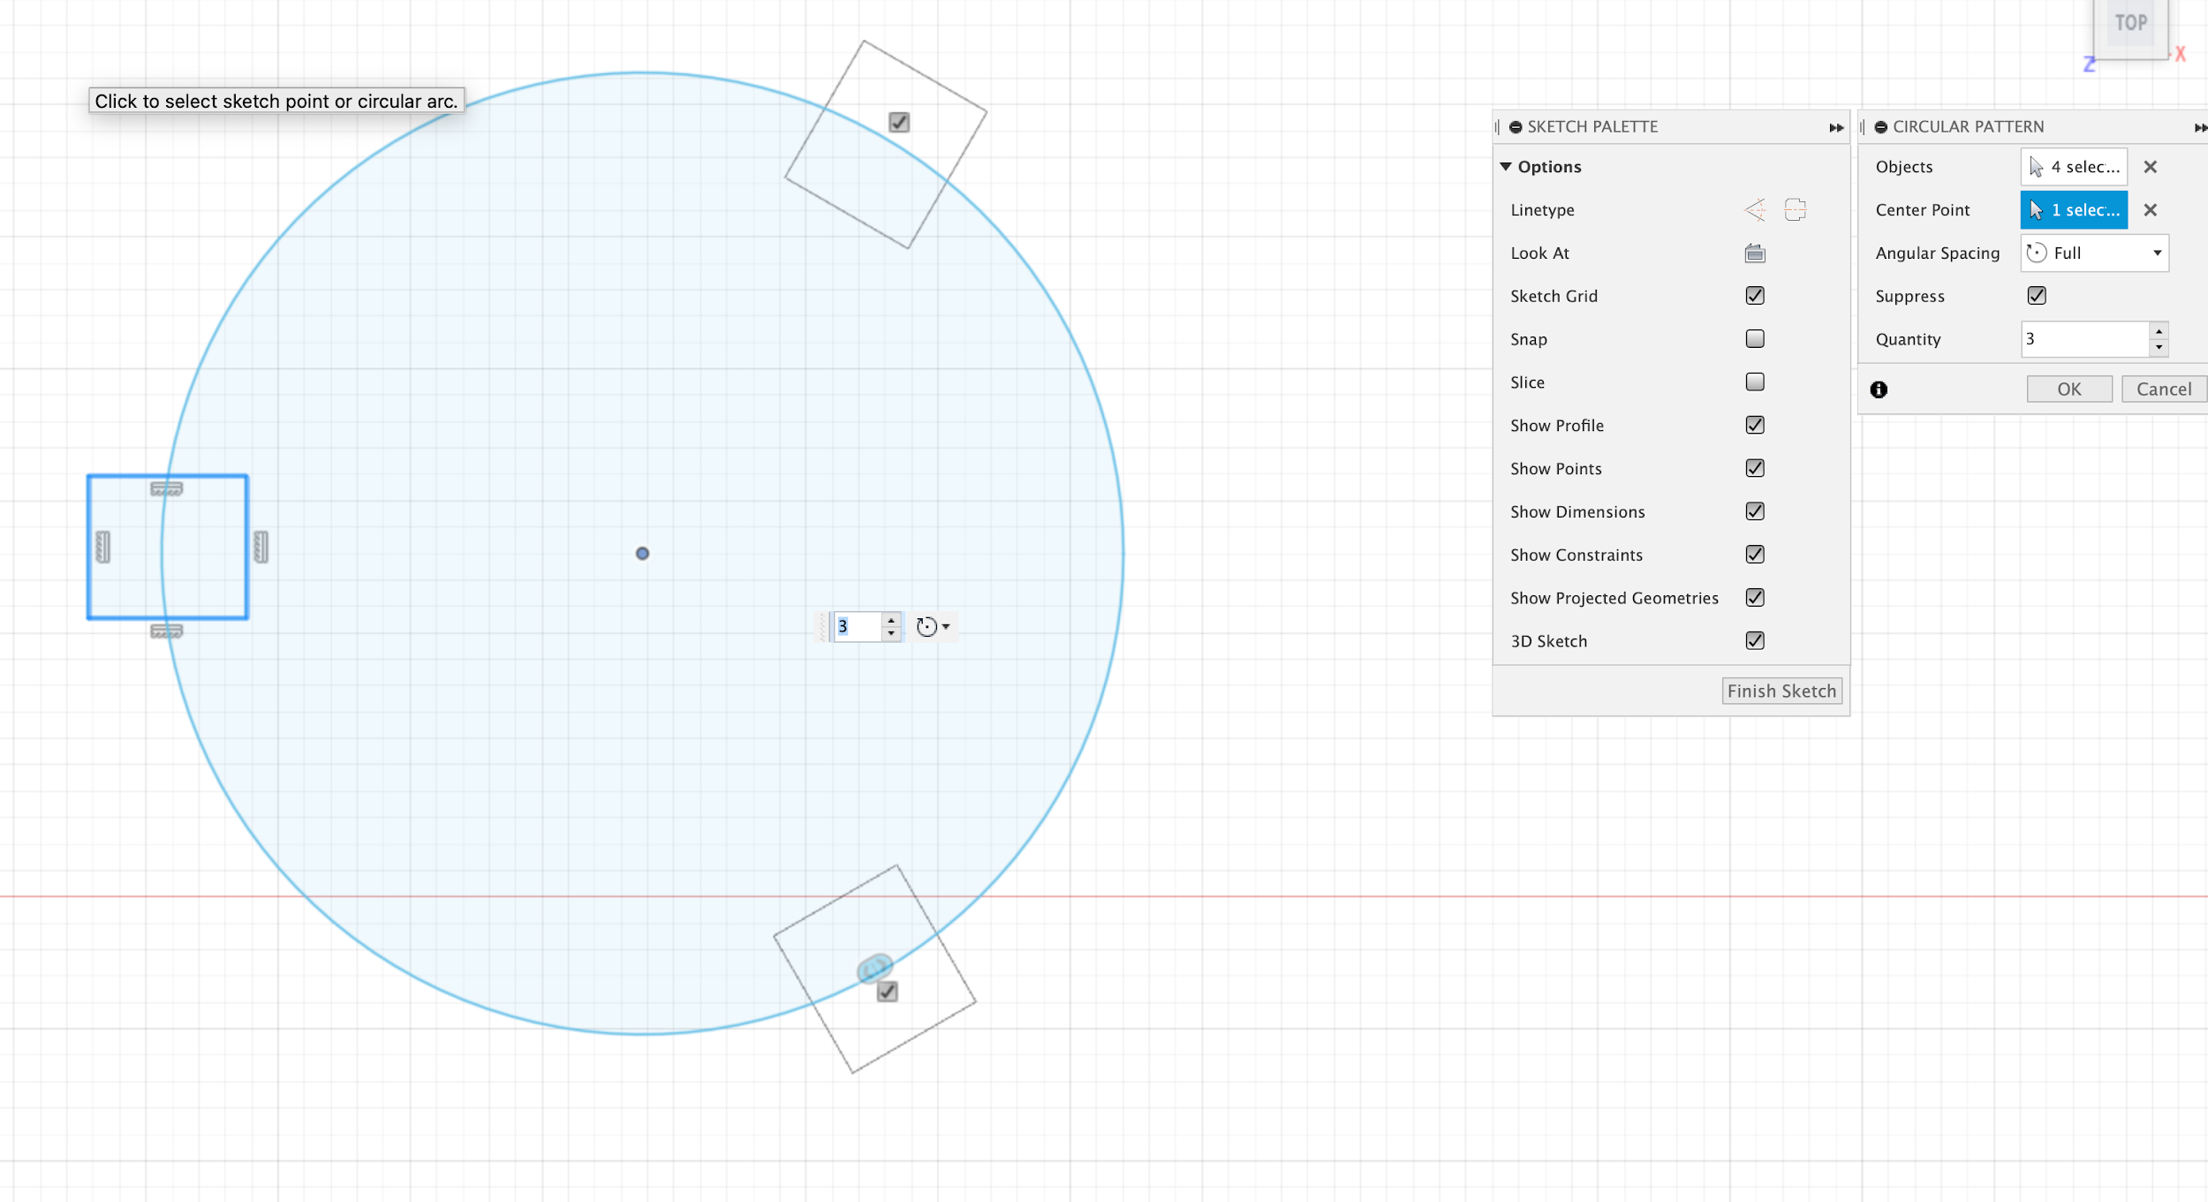

You can adjust quantity and spacing here:

# 

Once you’re done, click “OK!”

# Rectangular Pattern

Uses: for modeling rivet / gusset holes

Not tediously placing things

Also better for not causing Fusion to crash when you want to create lots of little things

How to example:

1. Place what you want to be patterned on the sketch + a line with the direction you want it to be patterned
   1. 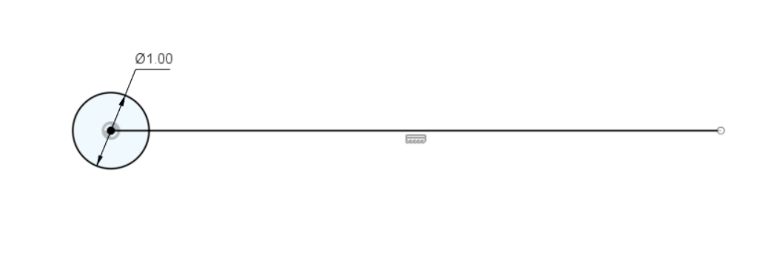
2. Decide what you want patterned and what will be the direction:
   1. 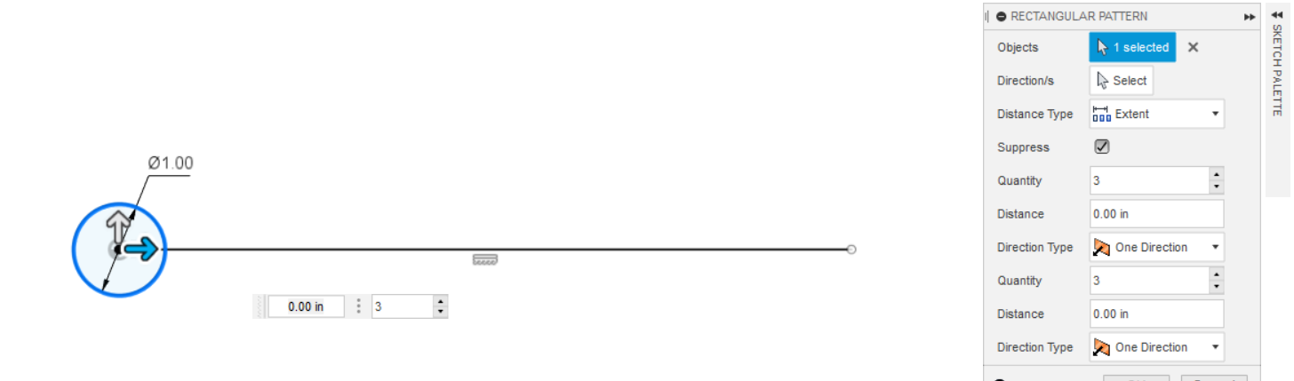
   2. 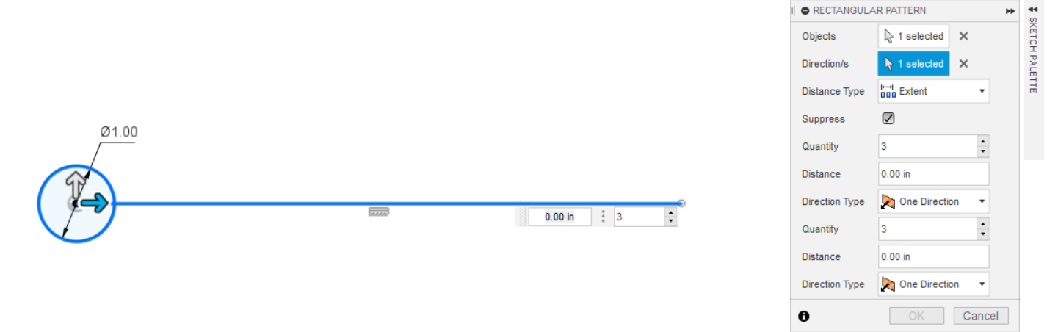
3. Quantity: how many you want. Distance: the spacing between each object / circle. For a circle it’s the distance between the origin points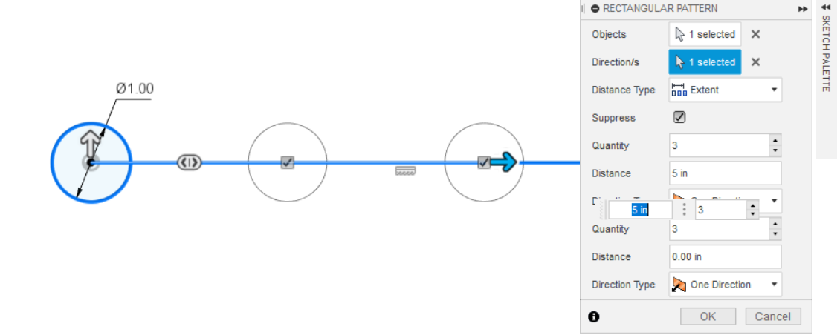
4. Play around with it:
   1. You can have it going two directions too:
   2. 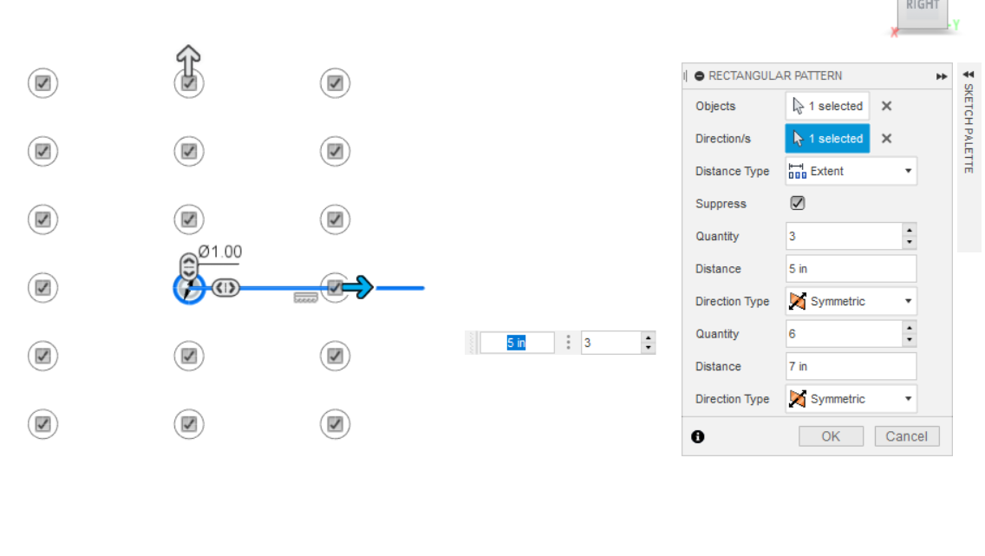
   3. Pretty cool huh?

Click “OK” after you’re done.